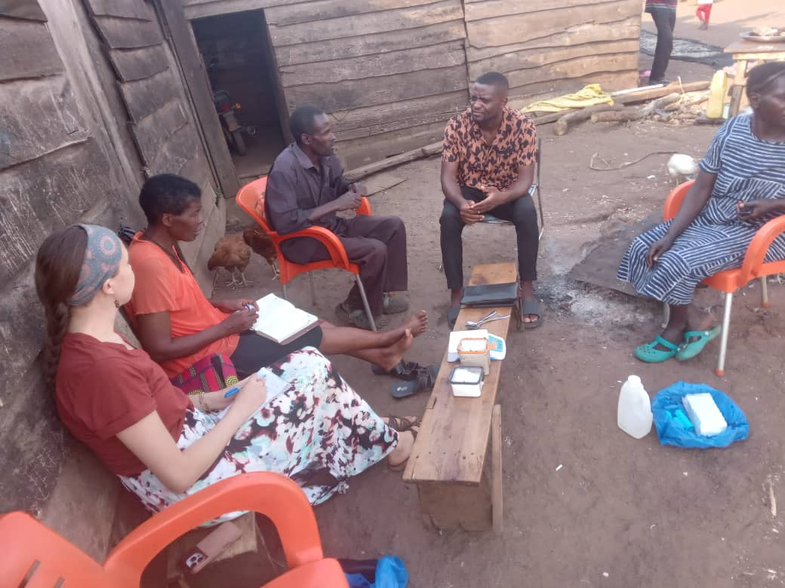

**Contents**

**Students & Visitors** 2

**Water Sources** 3

**Home visits** 10

**Quarterly Trainings** 11

**The Cookstove Project** 12

**Health Centre Visits** 14

**ORTube Project** 17

**Stories from the field** 17

**AOB** 18

**Students & Visitors**

We had the pleasure of hosting Calvin Tabetah and Ruth Sofi in February. Calvin is a fourth-year medical student at George Washington University, where he is actively involved in various initiatives. His primary focus while working with us was on the ORTube project, but also engaged in other Omni med activities. He described his experience with Omni Med as exceptional and thoroughly enjoyed working with the staff and the VHTs. He looks forward to future opportunities to collaborate, and continue making a difference.

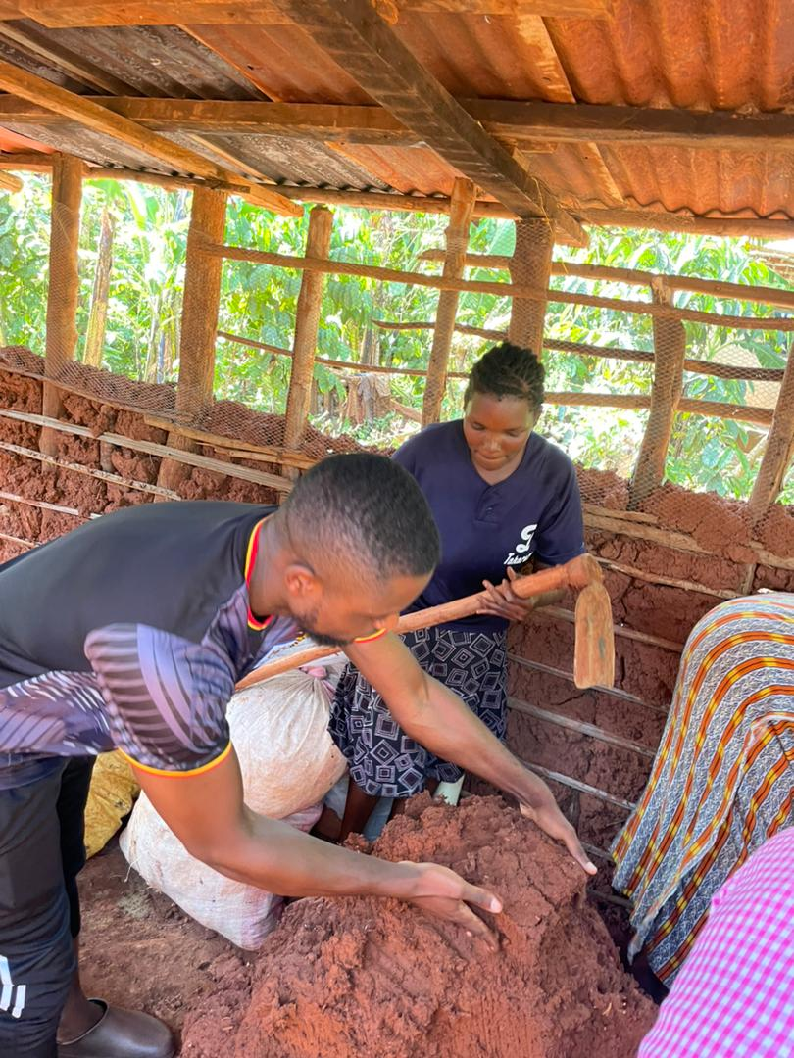

*Calvin (L) with one of the cook stove masters(R)during a cook stove demonstration*

Ruth is a fourth-year medical student at Touro College in New York, with a strong interest in pursuing a career in Psychiatry. Her dedication to mental health was evident during her two-week stay with us. We thoroughly enjoyed working with her, and are grateful for the valuable contributions she made to Omni Med.

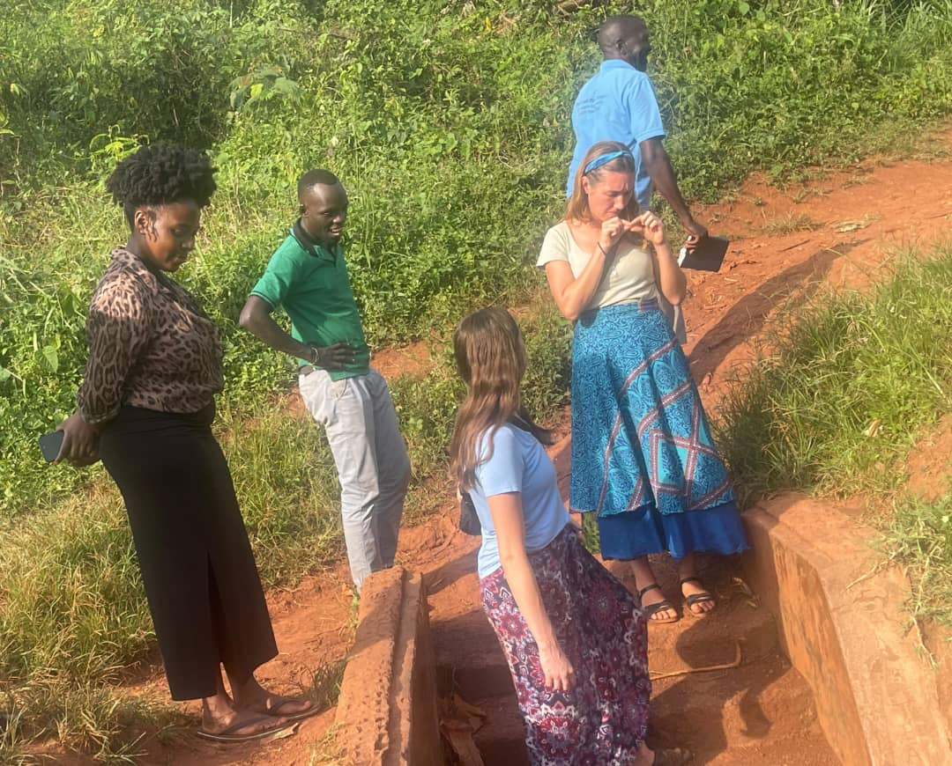

*Ruth(far left) during a water source visit*

**Water Sources**

Omni med staff visited eight water sources in the month of February.

The first water source we saw is called Nabadda water source located atButinindi village. It is a protected water source that was constructed by the RUWASA project on 17th/1/1997. It is in fair condition but will need drainage and vegetation clearance by the community. This water source serves the entire village with over 150 households, as well as a nursery school.

During our conversation with the VHT of Butinindi village, she reported that some community members do not boil drinking water due to a lack of containers to store it. Regarding drainage, she noted that a committee is responsible for maintaining the water source, but unfortunately, the drainage process is often delayed. Calvin our volunteer suggested installing signs in “Luganda” at each water site to physically remind people to boil water. And to advise community members to preserve a specific jerry can/container for storing drinking water after it has been boiled.

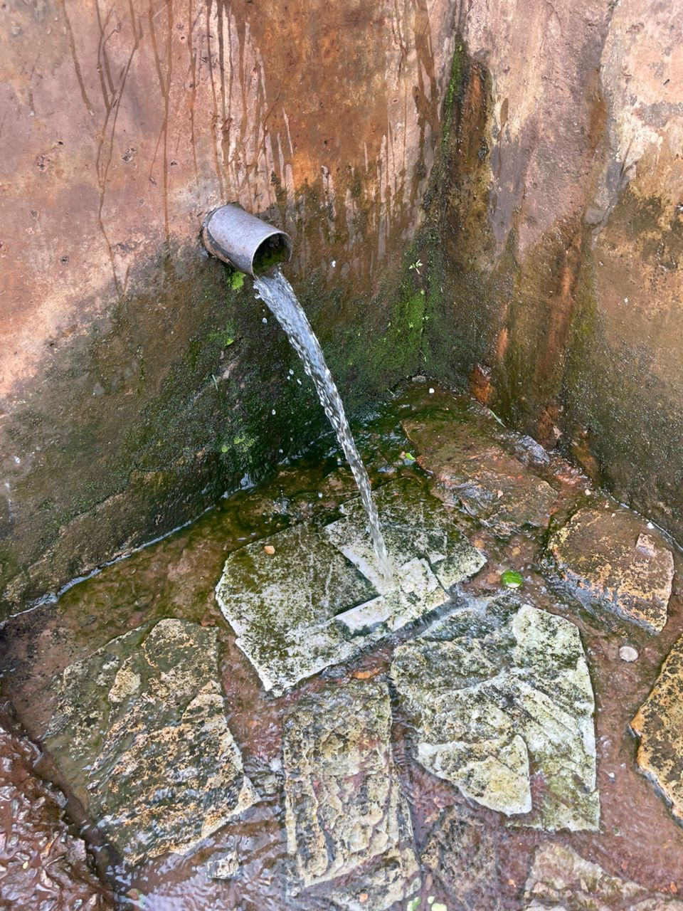

*Nabadda water source located at Butinindi village*

Secondly, our staff visited Nsambu water source located at Mpumu village. It is a protected water source with good water flow, although it does require some drainage improvements. It serves the entire village, including a primary school called St. Thomas.

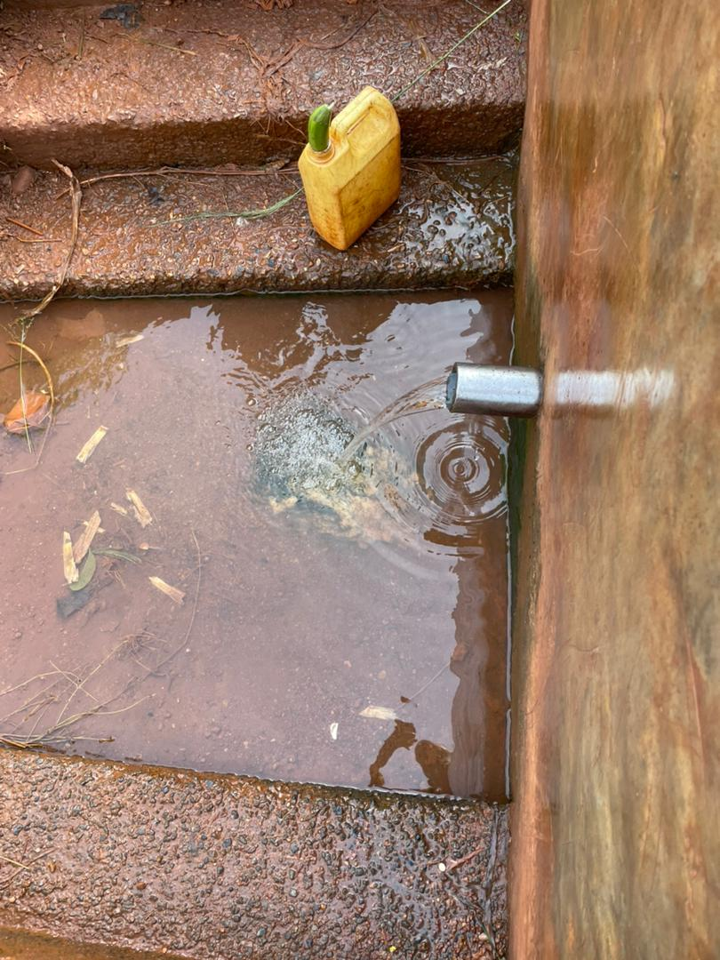

*Nsambu water source located at Mpumu village*

The next water we saw is called Mpulidde water source located atKisoko village. It is a protected water source that was constructed by VECH Uganda in 2011. This water source has a poor flow rate that is a big complaint among the over30-40 households collecting water from it. This is partly attributed to its drainage which requires attention.There is also an open source above it that will need fixing. Planting grass in the surrounding area is a recommended step to help mitigate the problem.

One community member we spoke with, admitted to not boiling the water for drinking she collects from this water source because she believes it is relatively protected from contamination, with children not able to play from it. She also mentioned that she has been taking unboiled water her whole life and has maintained excellent health. Additionally, she cited her busy schedule as another reason for not boiling her water, as she often finds herself short on time. A second community member weighed in, confirming that most community members do not boil drinking water.

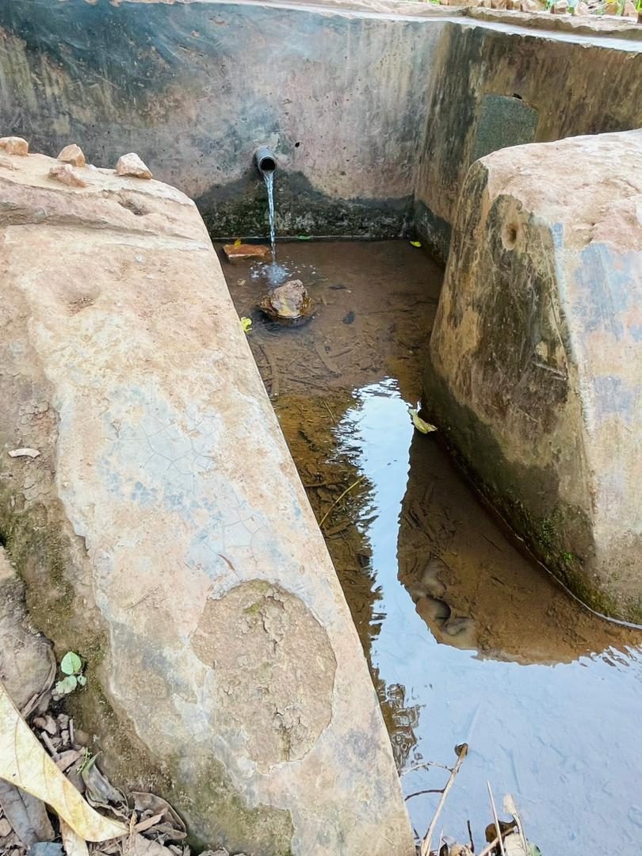

*Mpulidde water source located at Kisoko village*

We also saw another water source in Kisokovillage, which was constructed by the RUWASA project. It supports more than 100 households, has a heavy flow and is managed by a committee led by Mr. Kato. Drainage is necessary, and even though there is a crack in the wall, it has not affected the supply.

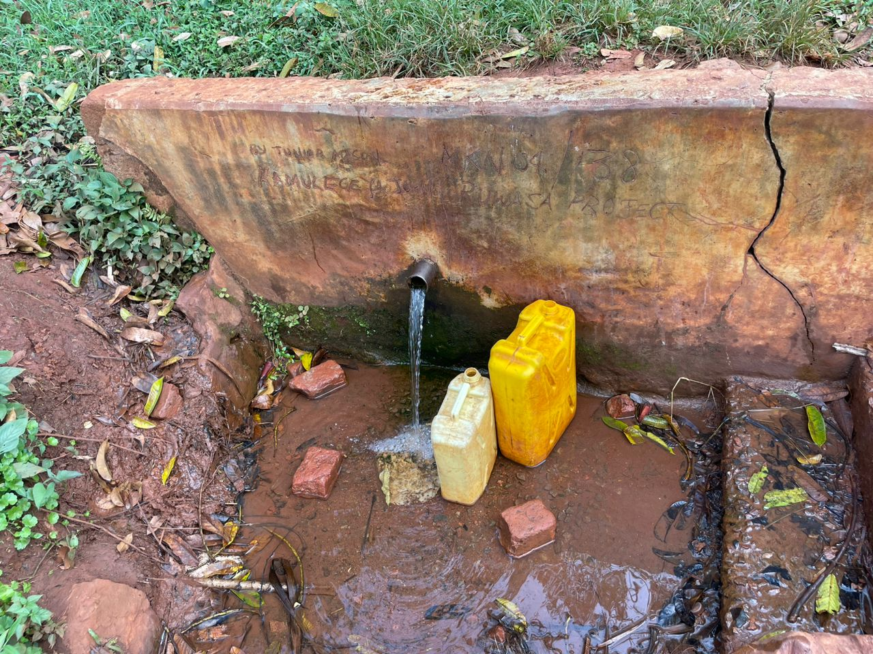

*A protected water source at Kisoko village*

Our staff visited an unprotected water source in Bumbajja village. Being open, it is still exposed to animal contaminationtherefore will need to be protected. Despite its clear water with a little bit of algae in it, the surrounding thick vegetation poses a risk of harboring reptiles that could potentially harm people. Additionally, its flat topography will require technical expertise for construction.

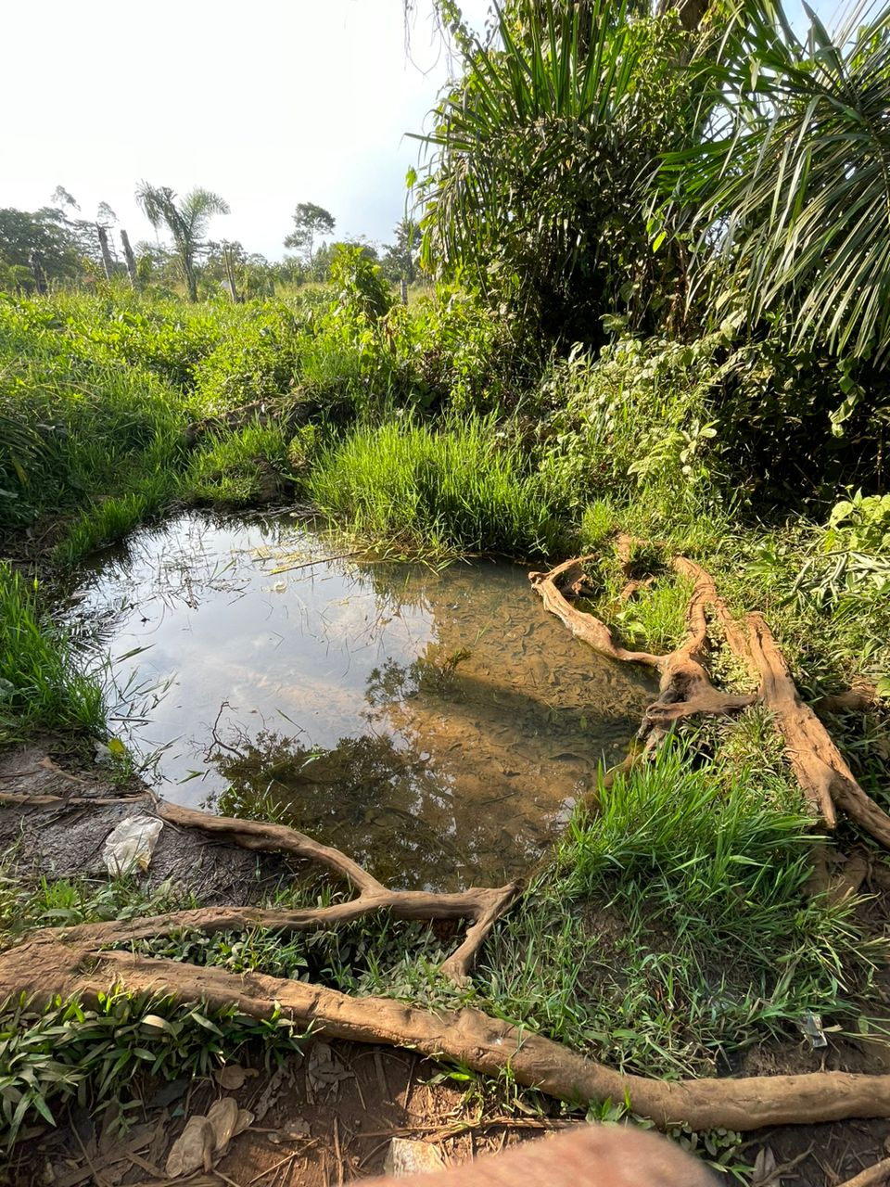

*An open water source in Bumbajja village*

Another water source we saw is a protected water source called Bayomba. This water source is located at Katente village and serves over 120 households. It was constructed by the RUWASA Project. It is in fair condition with pretty good water flow.

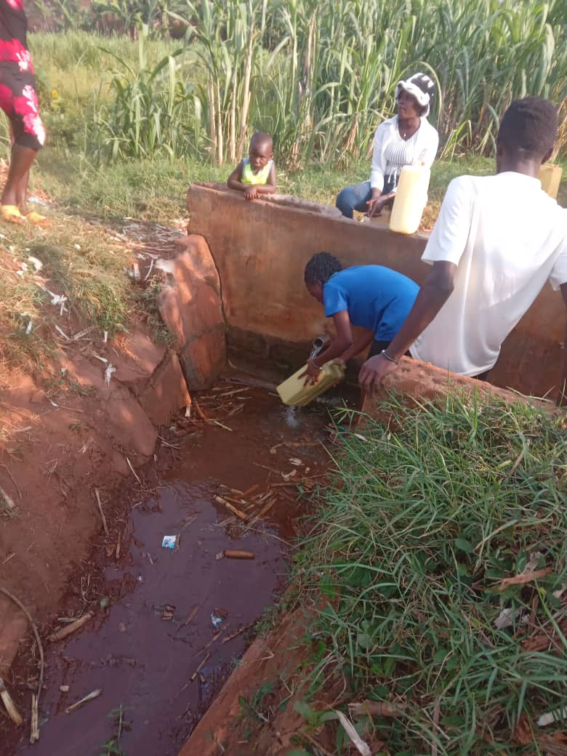

Bayomba water source located at Katente village

Our staff also visited Serunkuma water source also located at Katente village. Serunkuma is a protected water source that was constructed by Katente parish United group on 1/April/2022. It is in great condition, well maintained by the community, and serving over 20 households.

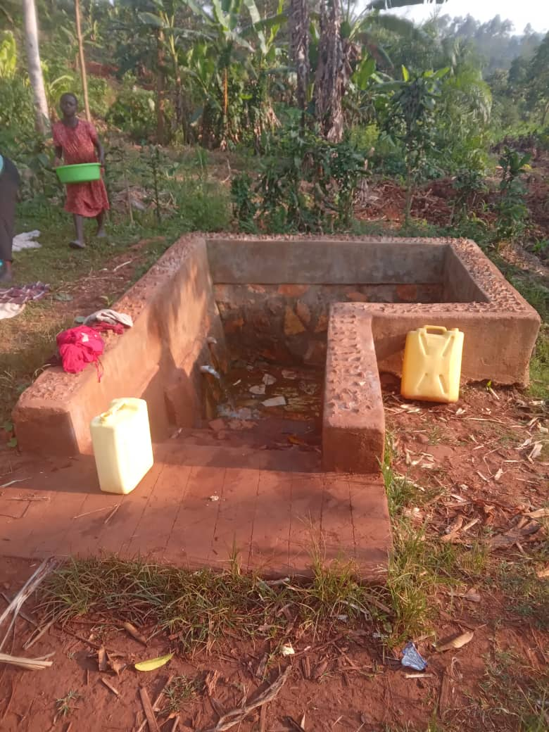

Serunkuma water source located at Katente village

Lastly from Katente village, we saw Mayanja water source. It is a protected water source that serves the biggest population in the village. Constructed by the RUWASA Project in the 90’s, about 120 households including a school collect water from this source. It is in great condition and the community takes proper care of it.

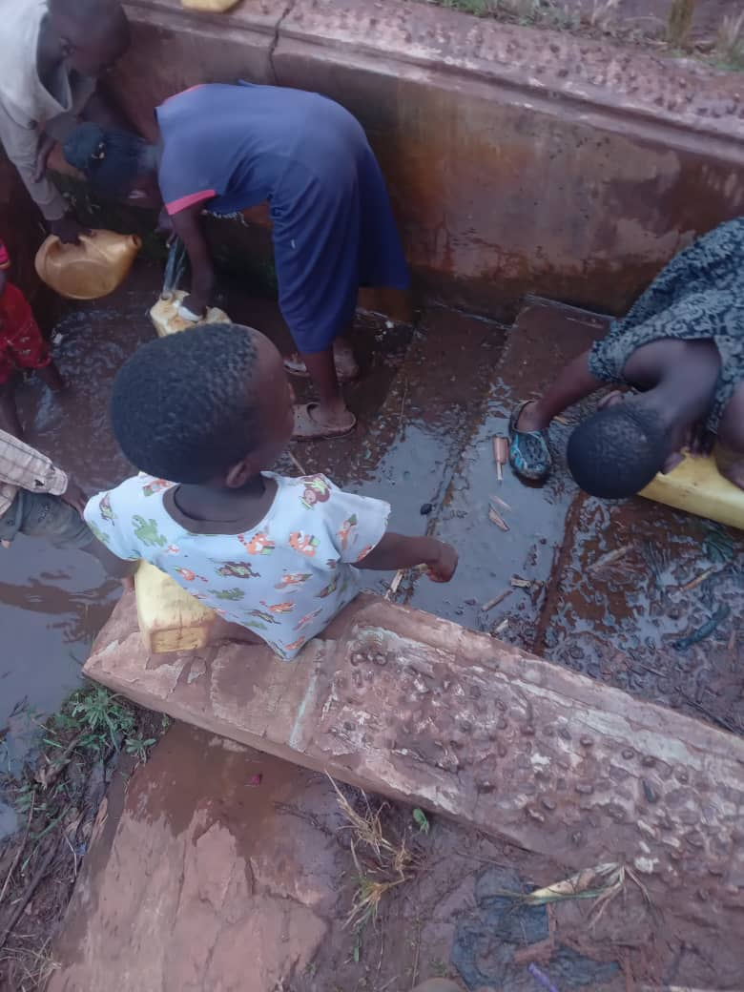

*Children collecting water from Mayanja water source*

**Home visits**

This month we held7 home visits and saw 16VHTs.

**Breakdown of home visits forFebruary**

| **DATE** | **VILLAGE** | **NO. OF VHTS SEEN** |
| --- | --- | --- |
| 3- FEB | NDWADDEMUTWE | 1 |
| 3-FEB | NANGA | 2 |
| 4-FEB | KAKALA | 2 |
| 10-FEB | KALENGERA | 1 |
| 12-FEB | KATENTE A | 4 |
| 14-FEB | BUGOLOMBE | 2 |
| 24-FEB | WABUSANKE | 2 |
| 25-FEB | BUZINDERE | 2 |

Average number of households that VHTs serve: 100

Average number of years each VHT has served in their village: 15

Commonest occupations of VHTs: Farmers

Common changes: Decrease in skin diseases, Increased access to safe water, More people follow prescriptions from health centers, General improvement in sanitation and hygiene, More people boiling drinking water, Increased construction of kitchens,Decrease in diseases like malaria, measles and diarrhea, Improved nutrition,Increased participation in immunization programs, Increased use of mosquito nets, Increased construction of pit latrines, Increased number of people testing at health centers, Increased hand washing.

Suggested topics by the VHTs: Healthy pregnancy, Hernia, Danger signs in children under five, Mental Health, Diabetes, Hypertension, Family planning, Tuberculosis, Monkey pox, Malaria, Diarrhea, Pneumonia

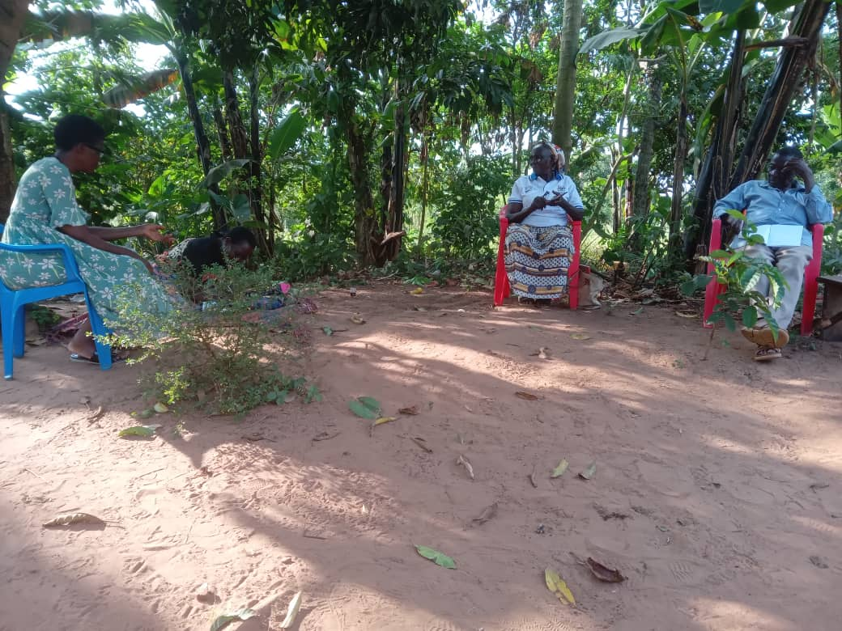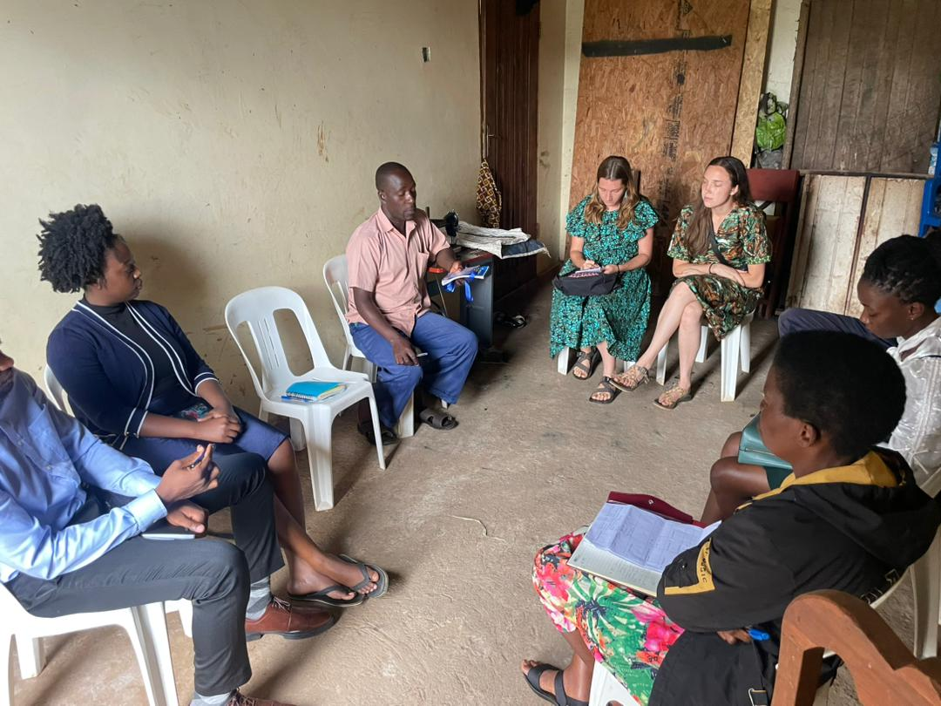

*Our staff and volunteers seeing VHTs during home visits*

**Quarterly Trainings**

Omni med staff held fivequarterly trainings in the month of February.

**List of Quarterly Trainings held in February**

| **DATE** | **PARISH** | **NO. OF VHTS** | **TOPIC** |
| --- | --- | --- | --- |
| 5-FEB | KIRONDO | 07 | MENTAL HEALTH COPING SKILLS |
| 7-FEB | SSAYI | 14 | MENTAL HEALTH COPING SKILLS |
| 13-FEB | TERERE | 09 | ORTUBE REVIEW |
| 20-FEB | MPATTA | 07 | MENTAL HEALTH COPING SKILLS |
| 26-FEB | KISOGA | 11 | MENTAL HEALTH COPING SKILLS |

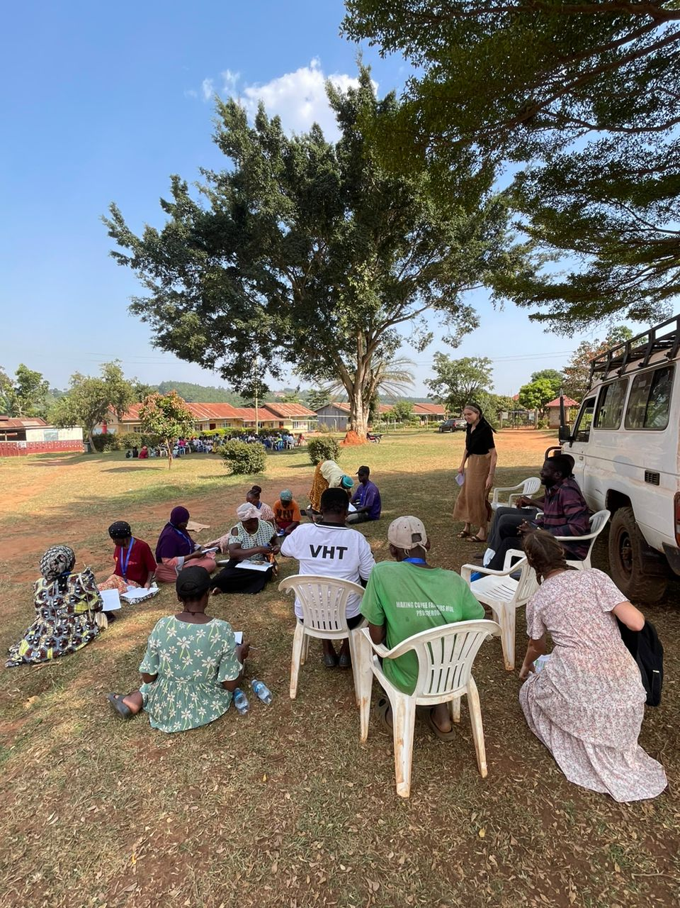

*Our staff and volunteers with VHTs during a quarterly training*

**The Cookstove Project**

Our volunteers had the opportunity to see a cook stove demonstration, which provided valuable insight into an alternative cooking technique that promotes energy efficiency and reduced fuel consumption. This took place at Kirondo village, led byJane and her amazing team from the Cook stove Project.

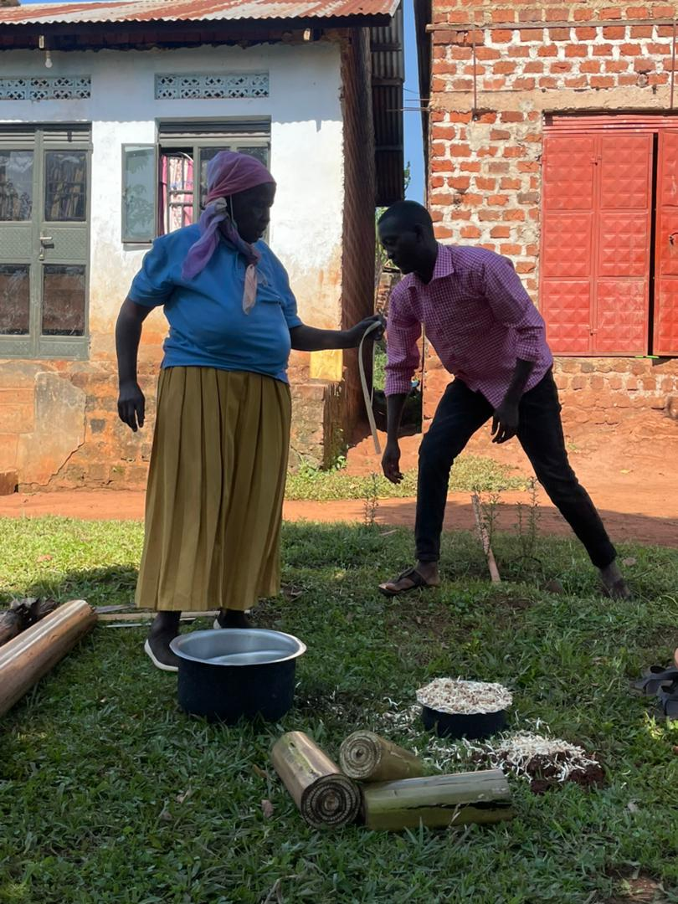

*Jane and a cook stove master during the demonstration*

Miquela our volunteer found it impactful and informative to see how the natural resources from the community can be effectively taken and used in such a beneficial way. As a doctor, the smoke concerns her a lot and to see it contained meant a whole lot to her. She added that it was amazing to see how they came up with the idea and are now able to help different families through different sustainability programs like training more cook stove masters and having a sustainability team to oversee the performance of the cook stoves.

For Calvin, it was truly a unique experience. He commended Omni Med for developing a remarkably cost-effective solution to the smoke problem that many impoverished African villages face. Having grown up dealing with this same issue himself in his village, witnessing this innovative approach was both inspiring and thought-provoking for him. He is now considering how this solution could be implemented in villages in Cameroon, and hopes to discuss the possibility with Omni Med, and other key stakeholders.

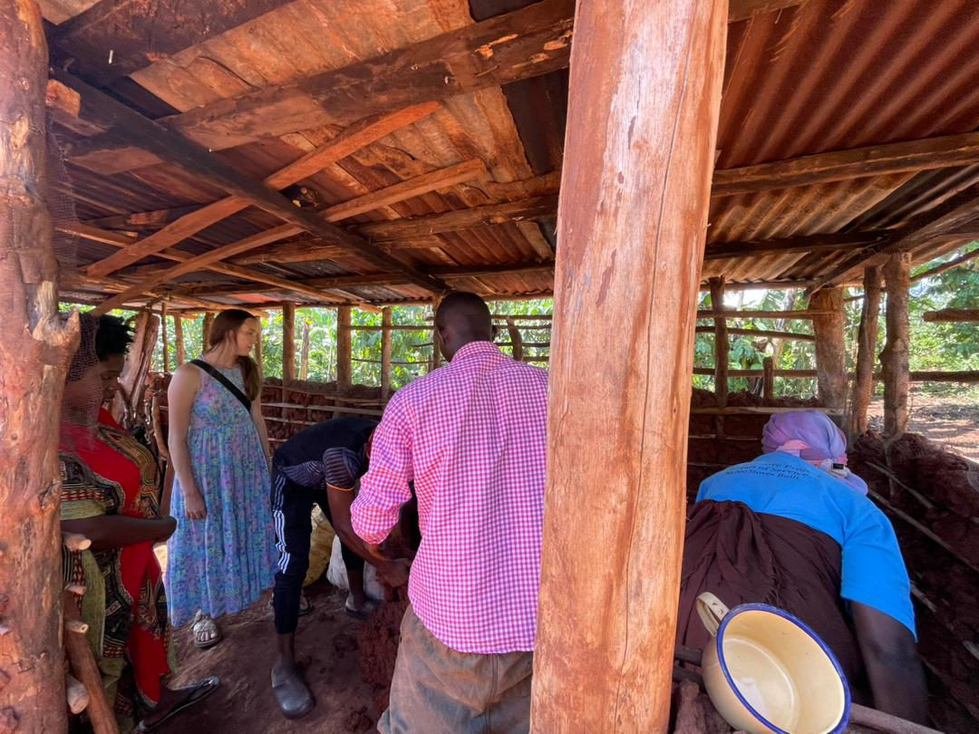 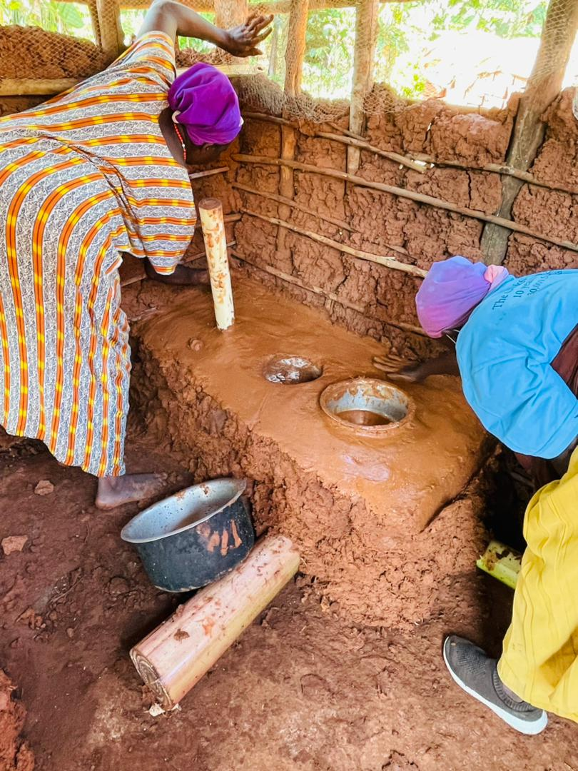

*Our volunteers(L) watching the demonstration and the cook stove team(R)doing the construction*

**Health Centre Visits**

Allan, Kristin, Miquela and Calvin visited Mukono General Hospital. They met with Dr. Kasirye one of the hospital staff who provided a brief overview of the hospital’s history. Established as a humble dispensary in 1945, where patients would receive treatment before returning home, the hospital has undergone significant transformations over the years. It was upgraded to a health center III in 1999, followed by an upgrade to health centre IV in 200. Most Recently in 2021, the hospital achieved its current status as a fully developed general hospital.

According to Dr. Kasirye, they deliver around 30 babies within 24 hours. Additional services offered include eye care, mental health, sickle cell disease management, immunization and family planning programs, cervical cancer screening, HPV testing with GeneXpert technology, community outreaches, and a youth corner to help with youth related problems. They plan on recruiting more specialists, such asa physician to strengthen their health care team. The hospitalserves over 800,000 people from Mukono and its neighboring districts.

They use test and treat policy to suppress viruses and mitigate the rate of transmission. Some of the challenges mentioned that the hospital faces include economic hardships deterring the government from providing for all the needs of the country, inadequate medical supplies that are quick to go out of stock, inadequate space to accommodate all the patients and staff so they end up sharing departments and lack of x-ray machines and other diagnostics like CT scans. Patients requiring diagnostic imaging services are currently sent to private hospitals, which are often not affordable to everyone.

There is also inadequate staff arising from the hospital’s inability to provide regular salaries stemming from limited funding allocations from the “National cake”.The Global fund supports the hospital with funding for TB and ARVs drugs. Reproductive health services and other unmentioned medications are provided for with funding from UN and other organizations. The government currently covers only approximately 4% of medication costs, creating a substantial gap that requires attention.

Calvin got to see the contrast between health care delivery in Mukono General Hospital and the United States which gave him a fresh perspective and reinforced his commitment to global health. He has always believed that, beyond being a physician, he has a responsibility as an African to give back to his community.

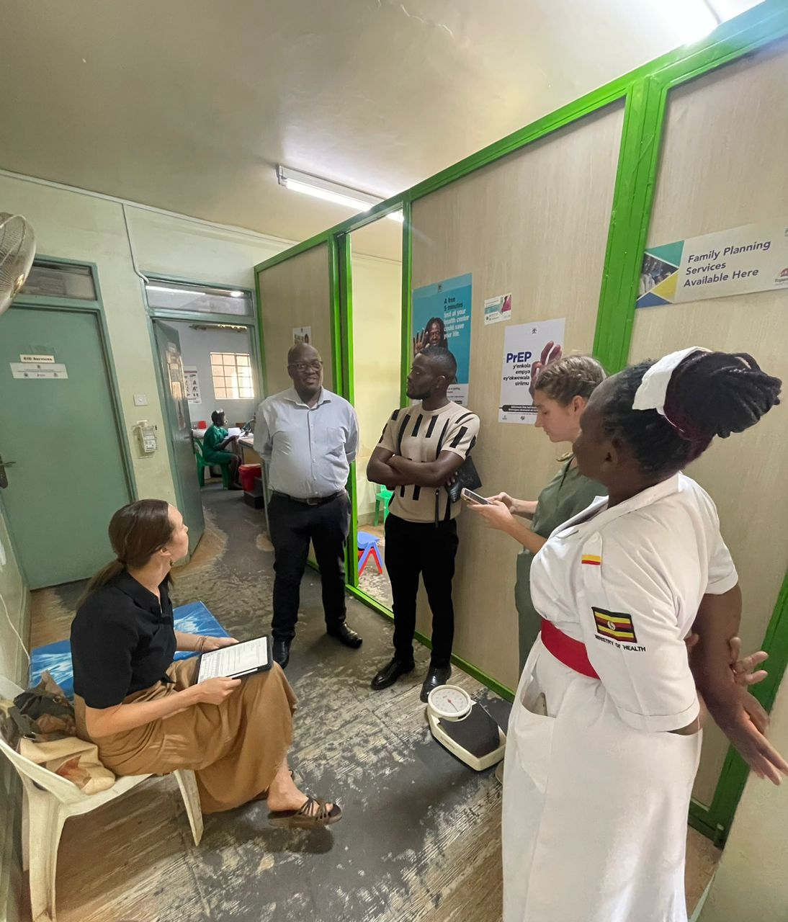 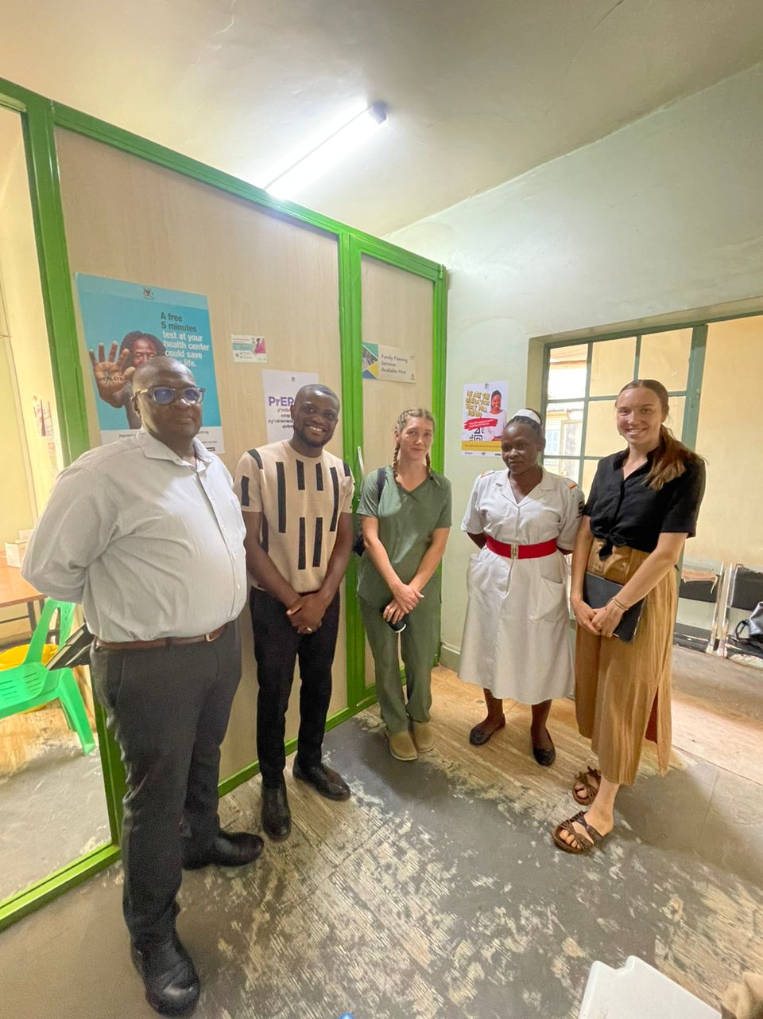

*Our volunteers with Dr. Kasirye at Mukono General Hospital*

Miquela visited the cervical cancer clinic and had an interaction with one of the health workers at the facility who said on average, the clinic gets approximately 10-15 people within 5 working days. She added that before administering the HPV vaccine to under-age girls, their parents have to consent. The ones whose parents do not agree are left out. The targeted age group for the vaccine is 9-10 years based on the average first sex experience of girls in Uganda which is 12 years.

According to the facility staff, VHTs hold meetings with their supervisors at the health center monthly to help plan and mobilize for outreaches. Cervical cancer outreaches in particular are conducted quarterly. Awareness for cervical cancer screening among women is done using community megaphones and gatherings. One of the major challenges facing the cervical cancer clinic is understaffing resulting in excessively long waiting times for the patients. The staff suggested centralizing biopsy services so that patients can receive their results on time. Following up patients is also hard due to lack of airtime for phone calls. Previously, USAID programs such as the Makerere University Walter Reed Project, provided occasional support with phones and airtime. However, the project’s temporary closure has forced the clinic to adapt to this new challenge.

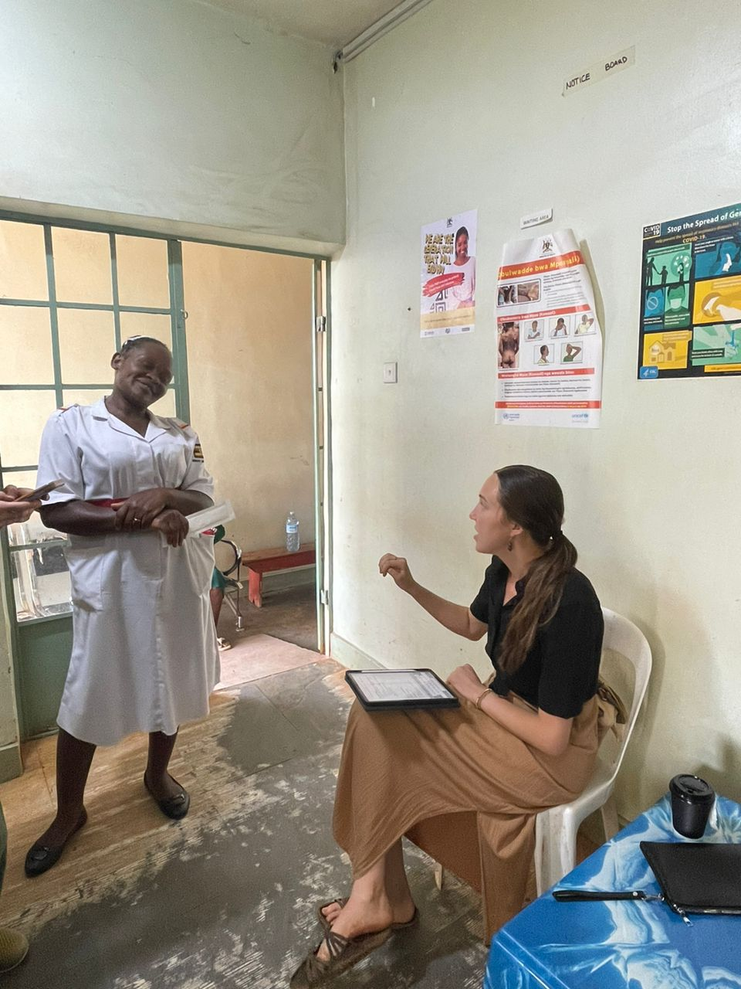 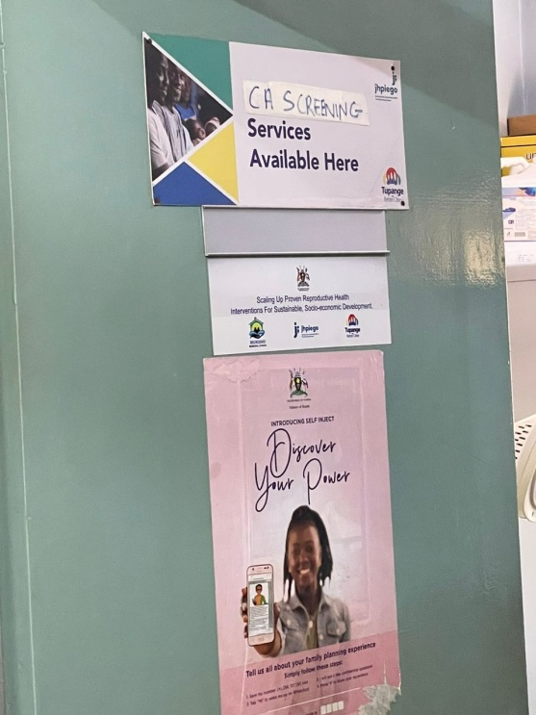

*Miquela interacting with one of the health center staff at the cervical cancer clinic*

**ORTube Project**

During Calvin’s time with Omni Med, he played a huge role in the ORTube project by training VHTs on ORTube use, ORS, and diarrhea management. He considers this as one of his most rewarding experiences of his time with Omni Med. His engagement with the VHTs, hearing about the challenges they face in their communities, and brainstorming solutions together was incredibly fulfilling. Their insightful questions led to productive discussions, making the training sessions highly interactive. Calvin believes the data collected will be invaluable for Jack and Jacob as they determine the next steps in this life saving initiative. He was truly honored to contribute to such an important effort and so was Omni Med for all the hard work and commitment he put towards this.

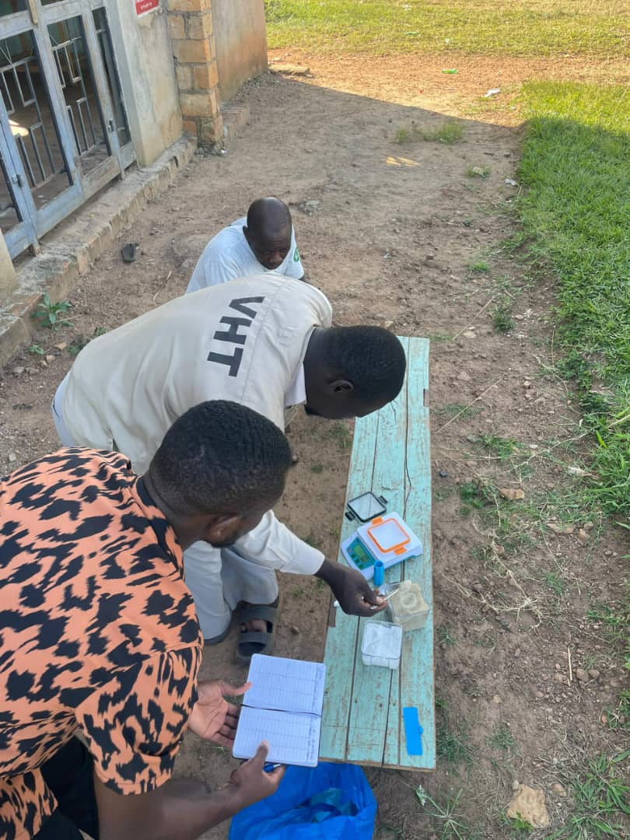 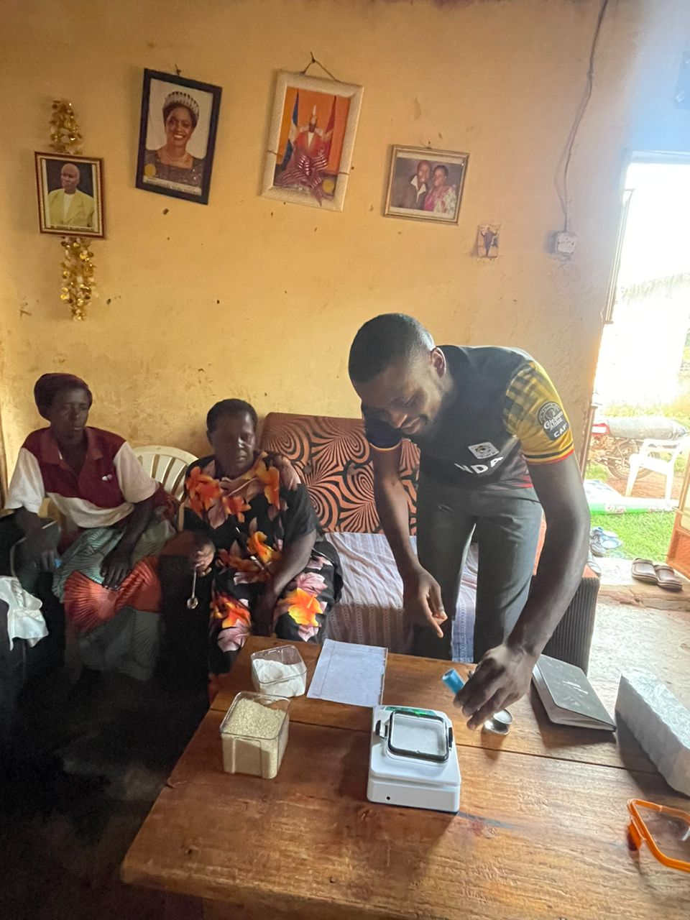

*Calvin showing VHTs how to mix ORS*

**Stories from the field**

During our interactionwith VHTs on one of the field visits, a VHT member from Kalengera village shared a remarkable success story. He recalled that in the past, residents would often resort to digging small holes for easing themselves, but thankfully, those days are largely behind them. He proudly reported that approximately 85% of households have constructed latrines. He also noted significant improvements in hand washing practices, with widespread use of tippy taps.

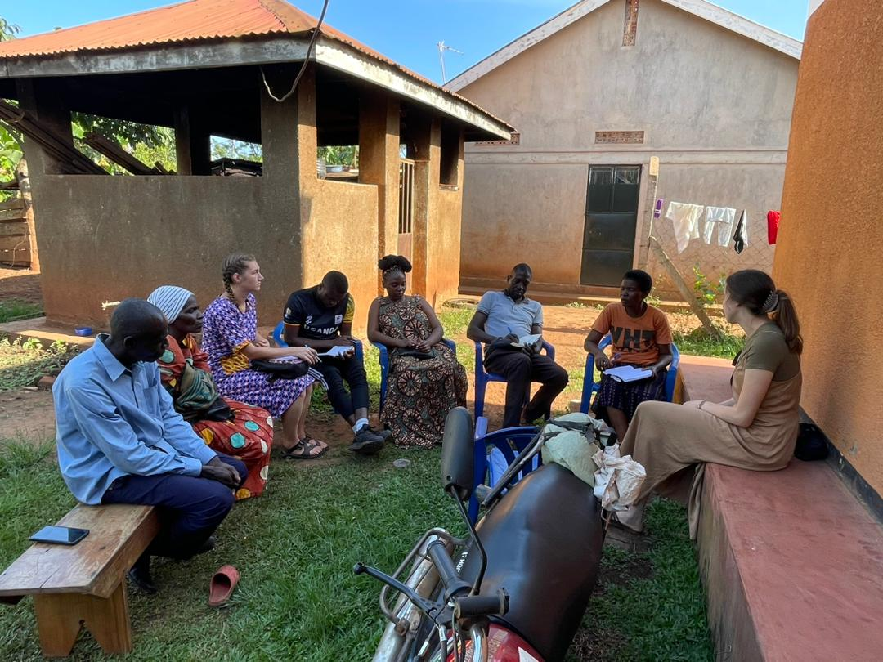

*Our staff and volunteers interacting with VHTs during one of the field visits*

**AOB**

Our staff Allan alongside our volunteers Ruth and Calvin, met Dr. Seggane Musisi, a Professor of Psychiatry and the former Chairperson of the Department of Psychiatry at Makerere University College of Health Sciences. He is also a senior consultant in the Psychiatry department at Mulago National Referral Hospital. Dr. Musisishared his life journey with them, recounting his experiences that have led him to where he is today. He later took them for a facilityvisitat Entebbe lakeside Hospital, where he currently works.

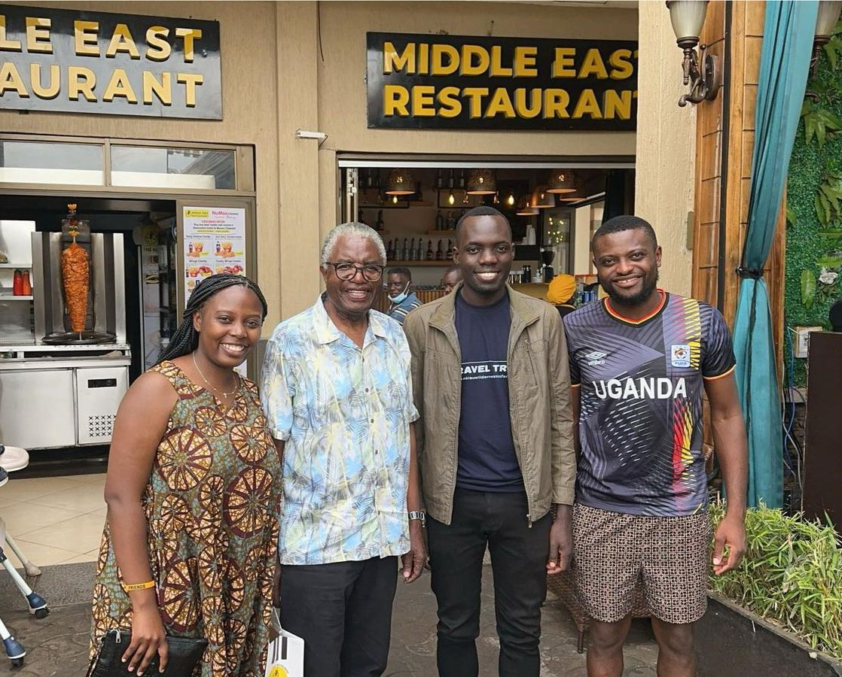

*(From the left) Ruth, Dr. Musisi, Allan and Calvin after the meeting*