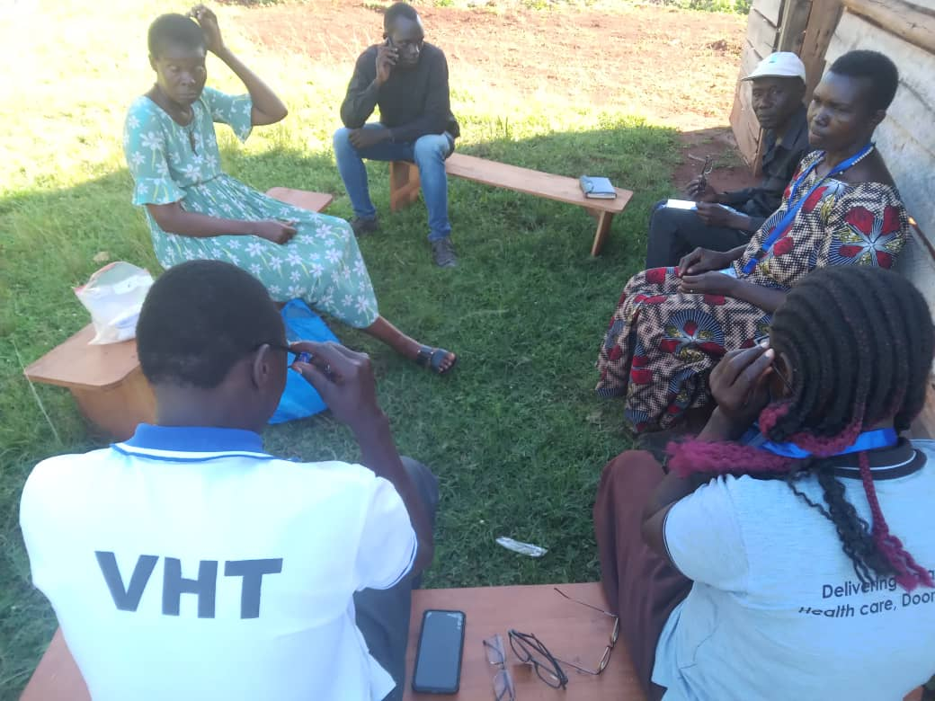

**Contents**

**Students & Visitors** 2

**Water Sources** 3

**Home visits** 11

**Quarterly Trainings** 12

**Health Centre Visits** 13

**VHT Volunteering Experience** 14

**Stories from the field** 17

**AOB** 18

**Students & Visitors**

This month, we bid farewell to our dedicated volunteer, Miquela who spent eight weeks with our team. Her main focus was developing a module on HPV vaccine, aimed at educating our VHTs. During her time with us, she engaged with various health care professionals from different levels of health centers in Mukono, gathering valuable insights and experience on HPV vaccine. We are grateful for her commitment and contributions.

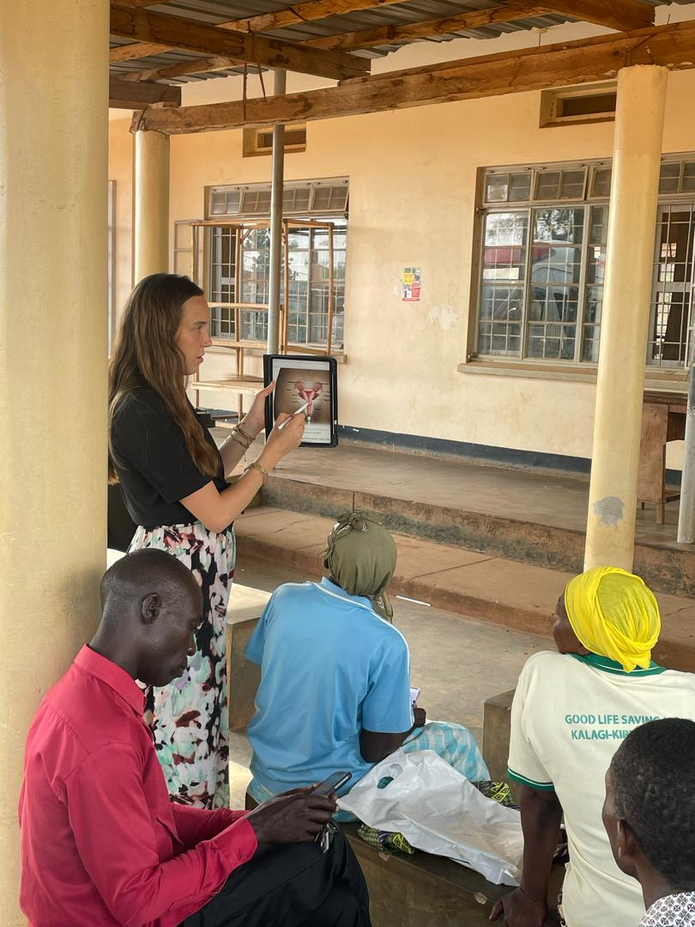

*Miquela(L)with VHTs during the training*

**Water Sources**

Omni med staff visited eight water sources in the month of March.

The first water source we saw this month is called Mpumuzze located at Mwanyangiri village. It is the 33rd protected water source to be constructed by Omni Med, completed on 14th/9/2022. It is still in great condition, well-maintained, and serves the entire village, including two local schools that is Mwanyangiri Primary School and Seeta College School, providing them with reliable safe water.

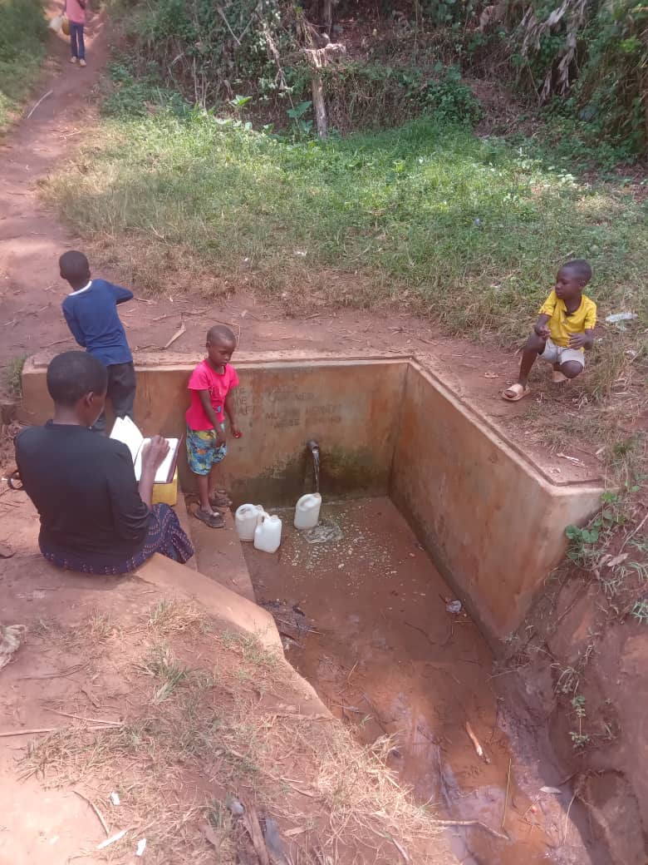

*Children collecting water from Mpumuzze water source*

The next water source we saw is known as Kyeddinganya water source located at Wankoba village. This water source is protected, and was constructed by the RUWASA Project on 9th/Mar/1994. However, despite its heavy water flow, it is in a quite sorry state, with issues including poor drainage and a huge crack in the wall. Livestock frequently stepping on the top of the water source is thought to have partly contributed to this damage.

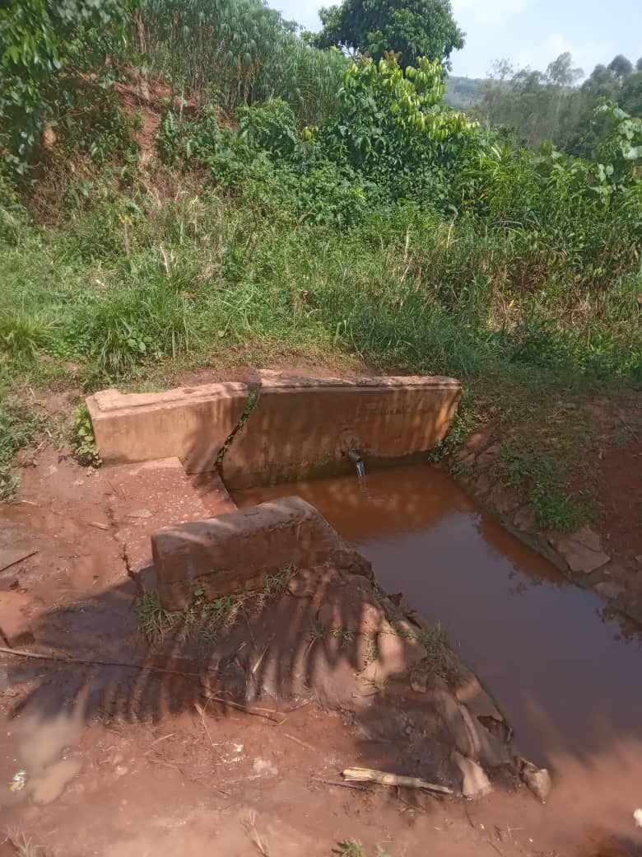

*Kyeddinganya water source in Wankoba village*

The third water source we saw is called Kamuje water source located at Nakasuku village. This protected water source constructed by Omni Med, and dedicated to Dr. Paul Farmer is still in good condition. It effectively serves over 50 households, providing a reliable access to safe water significantly improving the well-being of the community members.

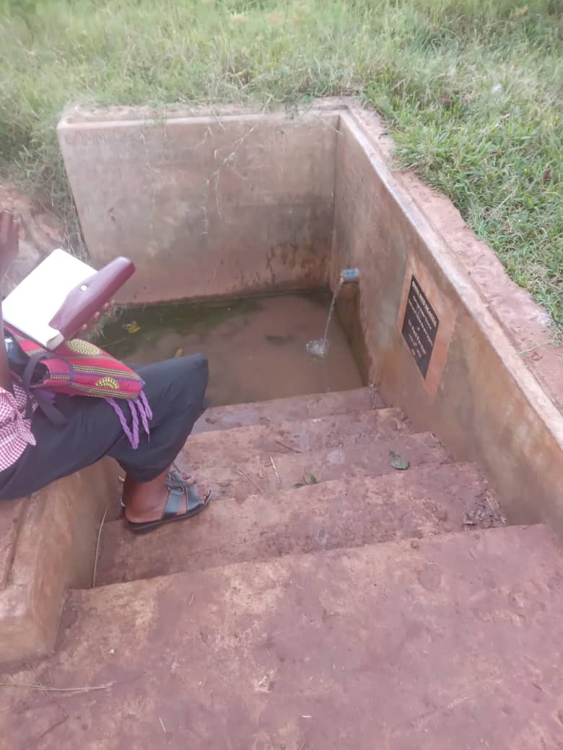

*Kamuje water source in Nakasuku village*

Next we saw Musoke Kitooke an open water source also located at Nakasuku village. Currently, it serves around 25 households. There is potential for it to be developed into a protected water source if the opportunity arises, which could further improve the water quality and reliability for the community.

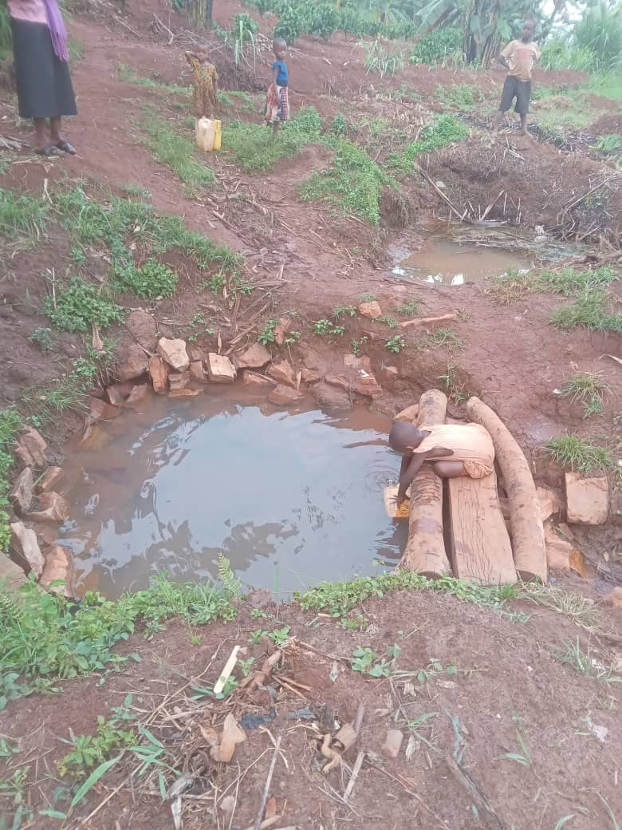

*Musoke Kitoke open water source in Nakasuku village*

Omni med staff visited Walugogo water source, located in Ntove village, which is a protected water source constructed by the RUWASA project on 10/12/1993. It continues to serve more than 50 households, as well as a primary school, and remarkably remains in great condition.

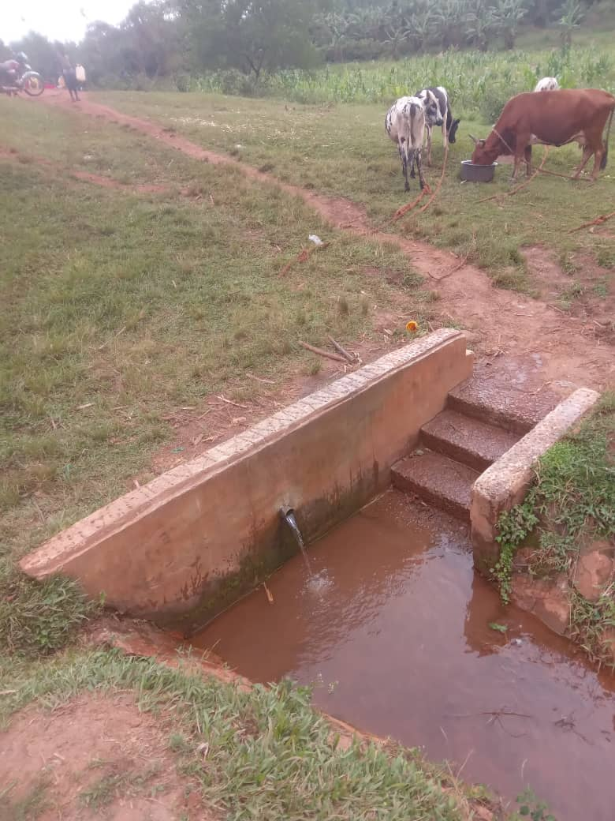

*Walugogo water source in Ntonve village*

We also visited Kasoma water source, located in Katente parish. It was constructed by Mukono district officials on February7, 2003 and serves the entire village. However, it currently faces an issue with poor water flow. Despite this challenge, it still remains a vital part of the village’s water supply infrastructure because there are not many options.

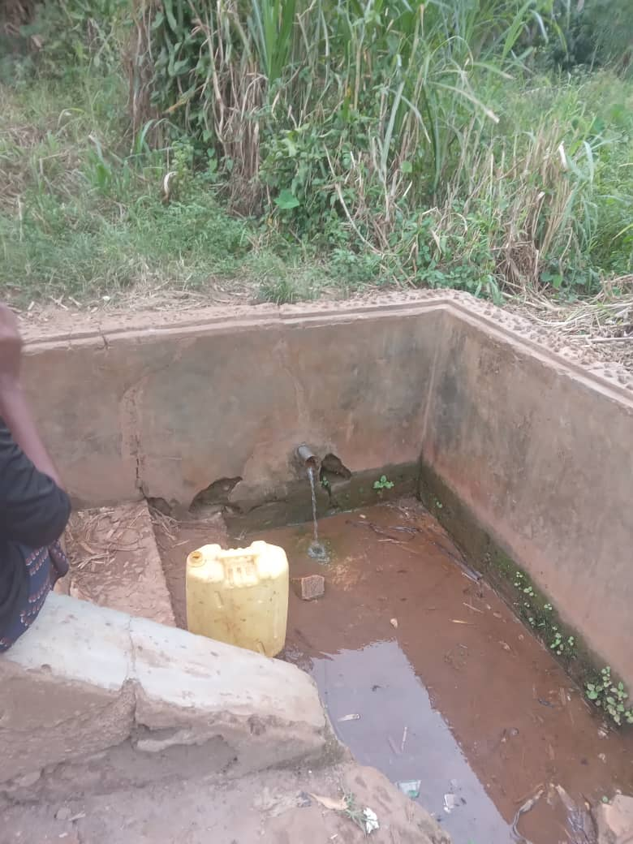

*Kasoma* *water source in Katete parish*

Our staff visited Nambuli water source, located in Bumbajja village, which was constructed by the RUWASA project on November 29, 1993. It is still in great condition, serving more than 100 households. However, nearby trees have been cut down, which could potentially affect the water levels.

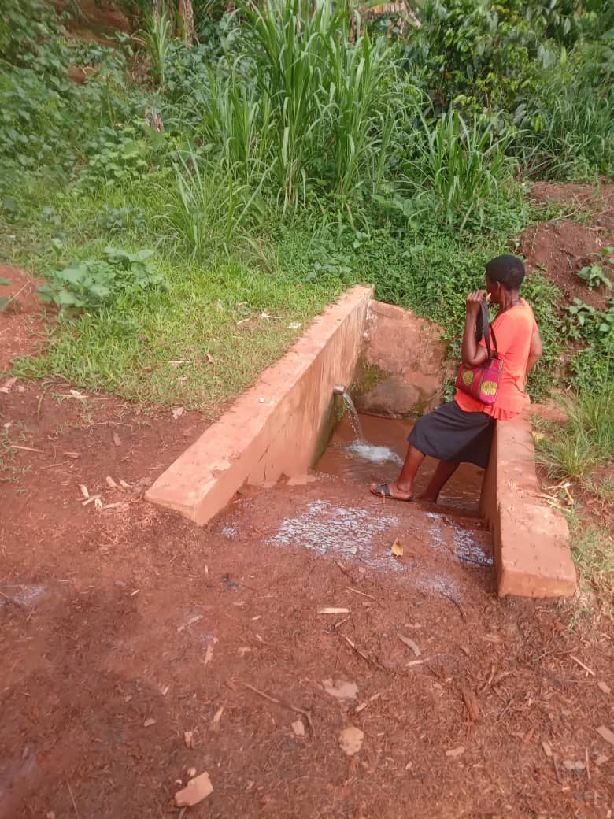

*Nambuli water source in Bumbajja village*

Lastly, our staff visited Biyasale water source, constructed by the RUWASA Project on November 13, 1993. Unfortunately, the water source is currently in terrible condition, with a broken wall causing water to flow out from multiple outlets. It is likely that the damage is a result of people stepping on top of the water source. Renovation will be needed to revive it to its original state. Despite its current state, it continues to serve the community with over 90 households collecting water from it.

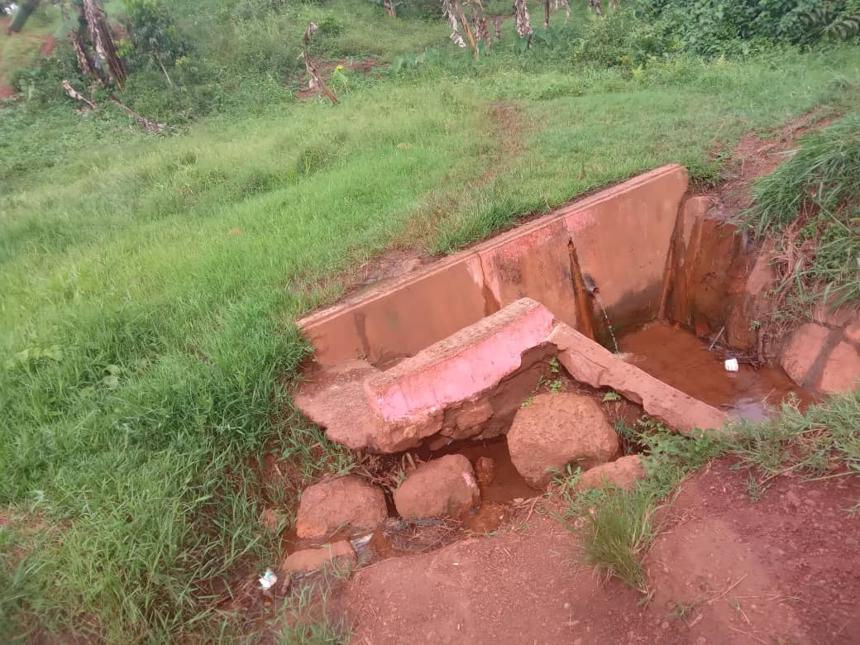

*Biyasale water source that will need renovation*

**Home visits**

This month we held 09 home visits and saw 35 VHTs.

**Breakdown of home visits for March**

| **DATE** | **VILLAGE** | **NO. OF VHTS SEEN** |
| --- | --- | --- |
| 3- MAR | MUBANDA | 7 |
| 4-MAR | NAMATABA | 2 |
| 7-MAR | GOLOMOLO | 4 |
| 7-MAR | BUNAKIJJA | 5 |
| 10-MAR | NTANZI | 5 |
| 17-MAR | KULUBBI | 4 |
| 20-MAR | LUGAZI | 1 |
| 24-MAR | WANJEYO | 3 |
| 25-MAR | BULEBI | 4 |

Average number of households that VHTs serve: 104

Average number of years each VHT has served in their village: 15

Commonest occupations of VHTs: Farmers, Teachers, Boda boda riders, Councilors

Common changes: More pregnant women attending antenatal, Improved relationship between VHTs and the community, General improvement in sanitation and hygiene, More people boiling drinking water, Decrease in diseases like malaria, measles, and polio, Improved nutrition, Increased participation in immunization programs, Increased use of mosquito nets, Increased construction of pit latrines, Increased number of people testing at health centers before treatment.

Suggested topics by the VHTs: Ebola, HIV/AIDs, Immunization, Ulcers, Worm infections, Lung infections, Male Circumcision, Mental Health, Diabetes, Hypertension, Family planning, Monkey pox, Malaria

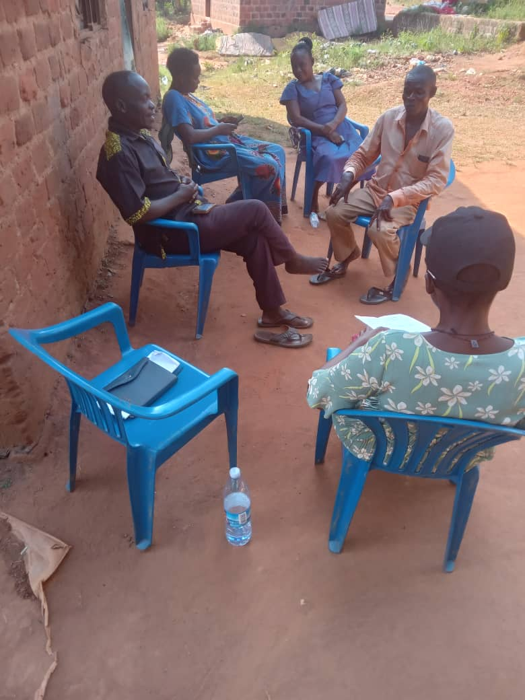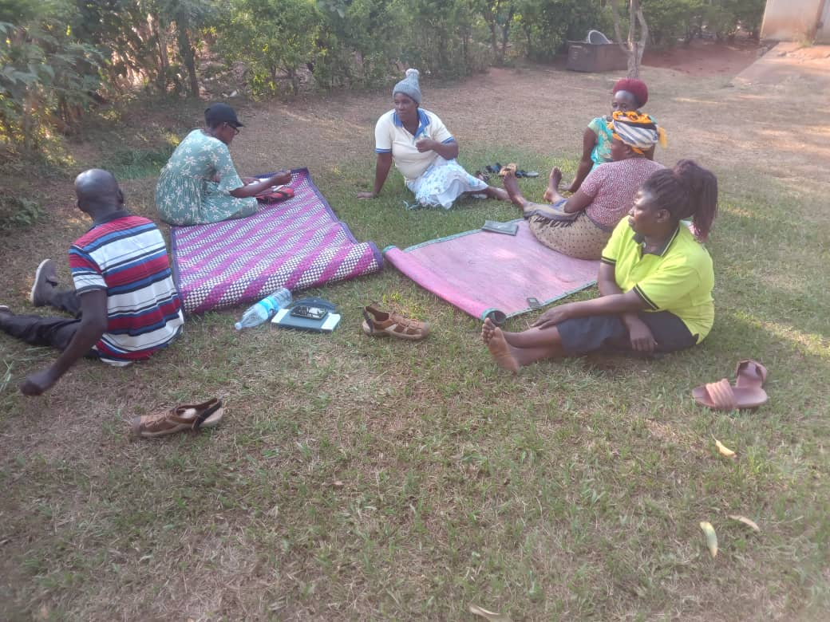

*Omni Med staff with VHTs during home visits*

**Quarterly Trainings**

Omni med staff held quarterly trainings in the month of March.

**List of Quarterly Trainings held in March**

| **DATE** | **PARISH** | **NO. OF VHTS** | **TOPIC** |
| --- | --- | --- | --- |
| 6-MAR | NAKIFUMA | 12 | CERVICAL CANCER INITIAL TRAINING |
| 21-MAR | MBAZI | 10 | MENTAL HEALTH COPING SKILLS |

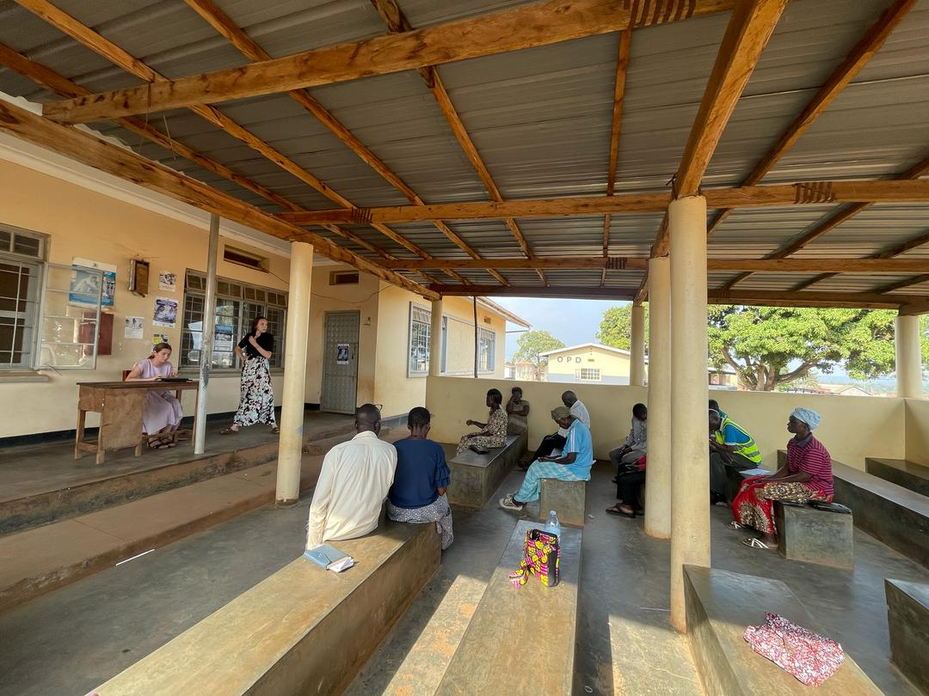

*VHTs of Nakifuma Parish during a quarterly training*

**Health Centre Visits**

Allan, Kristin and Miquela visited Kojja Health Center IV this month. They had the opportunity to interact with a health center staff, who affirmed that the health center administers the HPV vaccine. They also conduct outreaches in schools and communities. Some of these are carried out with request from Rosette, the VHT Coordinator at Kojja Health Center IV.

The facility also offers thermoregulation services with a 6-week follow-up. According to the health center staff, Health Center IIs only register, and take patient history before referring them to their facility. PAP smear patients are referred to regional referral hospitals in Kawolo, Nsambya, Kawempe and Mulago. Referral is based on the different stages of cancer. Only Stage 3 cancer patients are referred to the General Hospital in Mukono. The facility does not have a LEEP machine.

Our team also met with Rosette, who shared about community adherence to HPV and cervical cancer screening. She mentioned the different misconceptions and myths, surrounding HPV that are prevalent in communities. A common myth that she highlighted was that the vaccine affects the female uterus.

Additionally, she said that screenings unlike administering the vaccine is only done at the health center facility. The health center has helped spread awareness about cervical cancer by providing the VHTs with information to sensitize their particular communities.

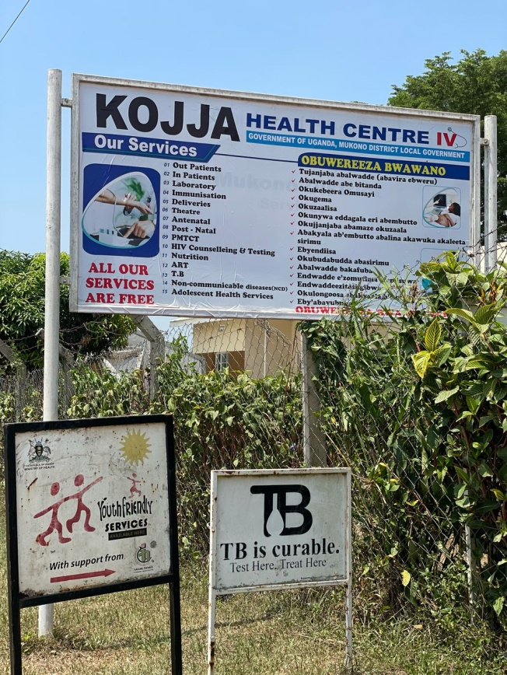 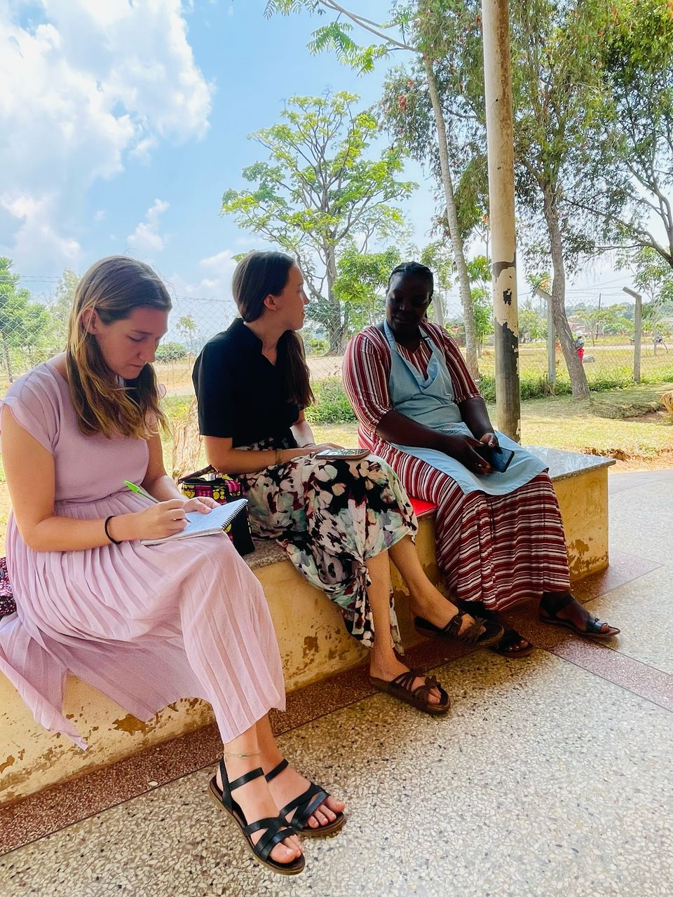*Kristin (L),Miquela(M) and Rosette(R) at Kojja Health Center IV*

Allan, Kristin and Miquela also visited Kyabalogo Health Center II. Through their interaction with one of the health center staff at this facility, they found out that this facility also administers HPV vaccine. They do this not only from the health center but also in communities around as part of their outreach programs. Most of these are done at Primary schools targeting female children between 9 and 10 years old. This is done during school time. VHTs help with mobilization. In case they come across someone who presents with symptoms of cervical cancer, they are referred to Kojja Health Center IV. They neither have a cervical cancer clinic, nor do cervical cancer screening at the facility.

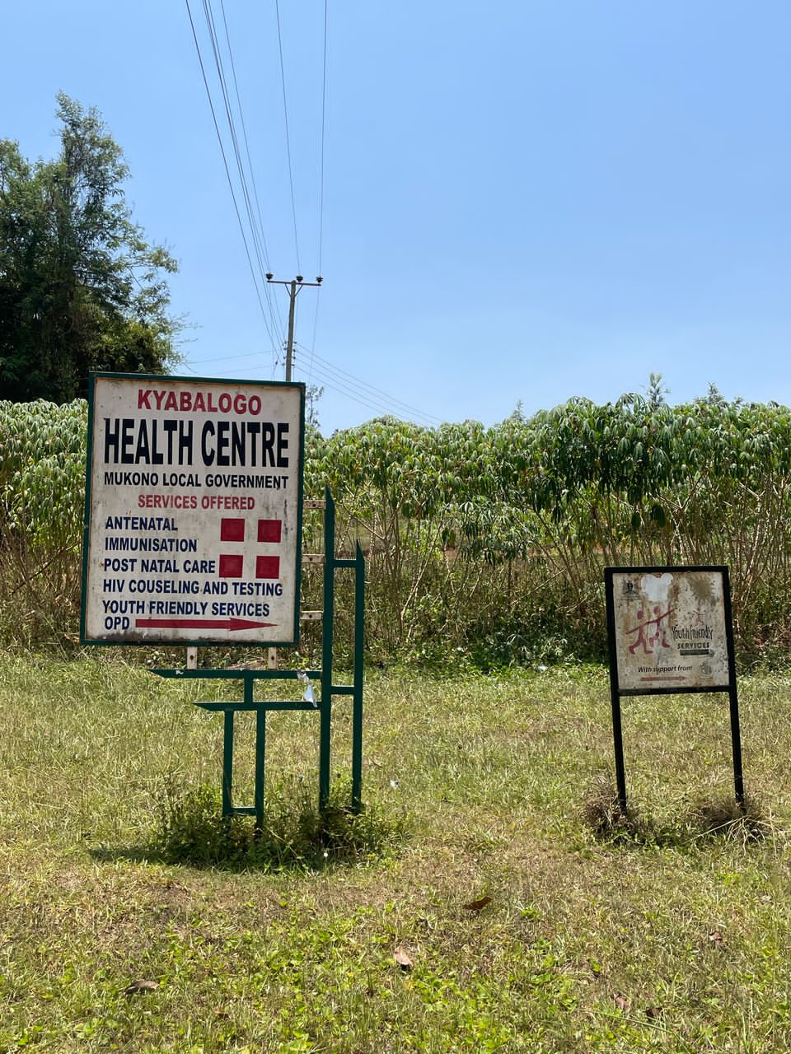 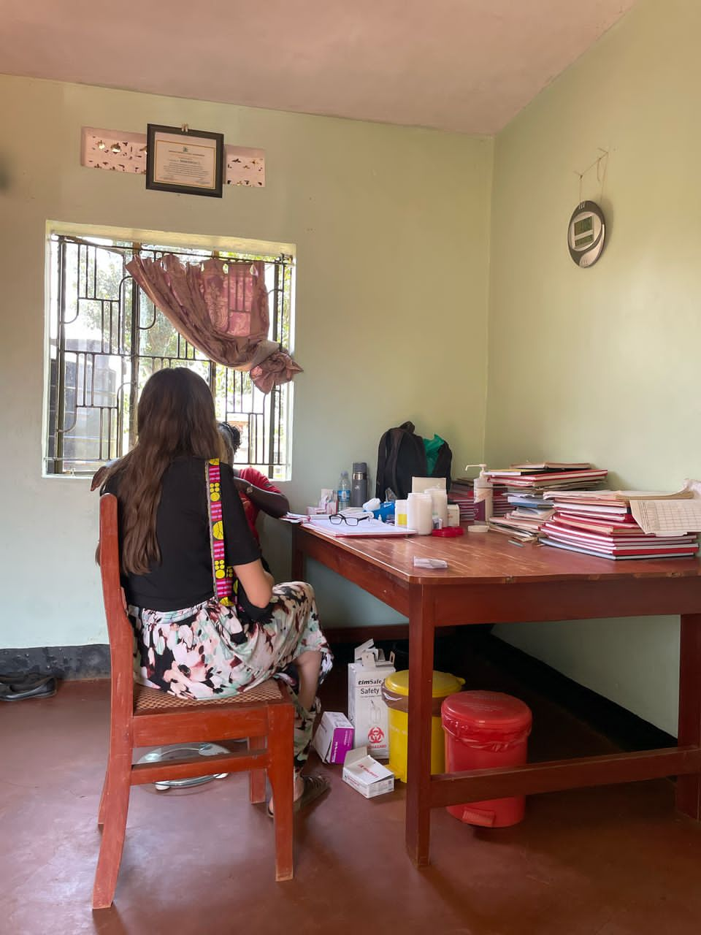

*Miquela interacting with a health care worker at Kyabalogo Health center II*

**VHT Volunteering Experience**

Many VHTs from various villages are actively engaged in volunteering at their nearest health centers, demonstrating their commitment to improving health care in their communities.

Herbert our VHT Coordinator at Seeta Nazigo H/C III mentioned that while at the health center, they take on flexible roles like delivering health talks to waiting patients, registering patients, doing simple laboratory tests, providing assistance to health care workers at the maternity and ART clinics and, cleaning the facility. The VHTs a part of the ENT program diagnose, treat and, follow up ear patients every Thursday.

According to Herbert, there are many more willing to volunteer but live a considerable distance from the facility. Omni Med provides them with a small stipend, that they use to buy water and snacks, to sustain them while they volunteer. Herbert further mentioned that he creates a schedule for the VHTs, but communication is challenging because some of them don’t have phones, making it difficult for them to receive updates or coordinate with the team. He added that there’s a pressing need to train additional VHTs to replace those who have passed away or dropped out due to factors like old age, ensuring continuity of health care work in the community.

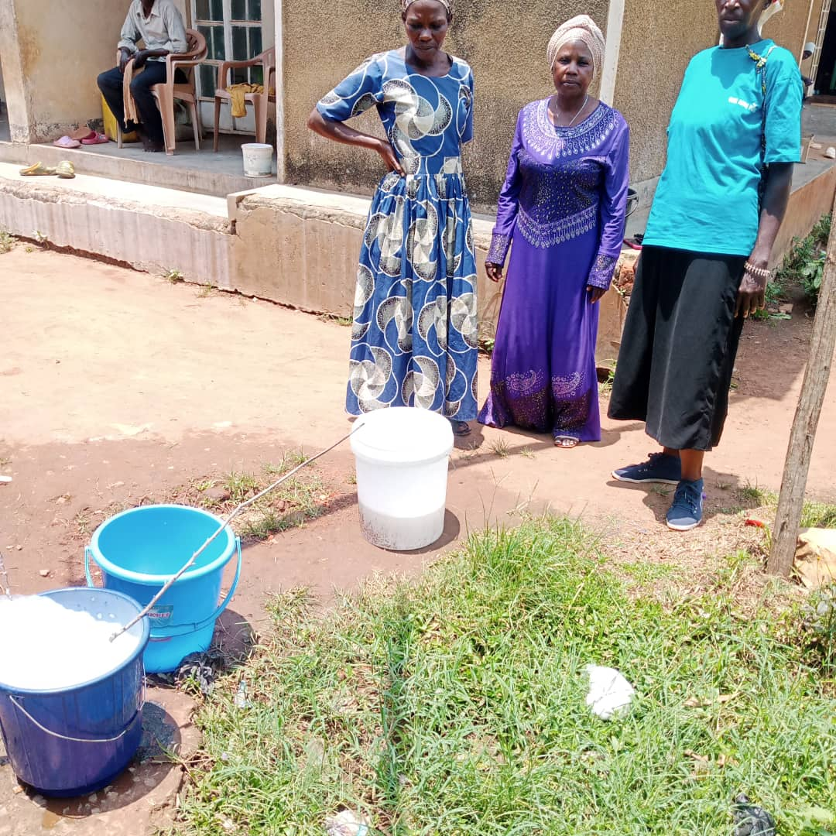

*Seeta Nazigo VHTs preparing water for cleaning the facility*

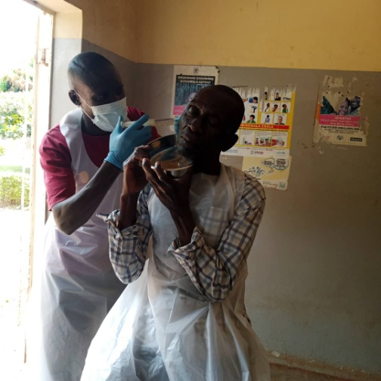

*A VHT seeing an ear patient*

Rosette our VHT coordinator at Kojja Health Center IV praised the VHTs, saying they have demonstrated remarkable dedication and commitment to their volunteer work at the health center. Throughout March, she worked with 30 VHTs. While at the facility, Rosette mentioned that they deliver health talks to patients, sharing the knowledge and topics they have learned from Omni med during quarterly training sessions. Furthermore, they refer patients to the facility and usually contact Rosette each time they do this.

According to Rosette, one of the biggest challenges they are currently facing is lack of uniforms to help with identification. She adds that it is hard for the VHTs to introduce themselves to patients without uniforms, which she also believes could help establish their credibility. Aside from this, they are doing an excellent job, and yielding positive results.

Additionally, their active involvement at the health center has opened up opportunities for them to be recognized and considered by other organizations. The government has also leveraged their contributions by involving them in key campaigns such as immunization efforts. In fact some VHTs are currently receiving training on vaccinating malaria, a program slated to roll out this April.

**Stories from the field**

One of the VHTs from Bunakijja village mentioned championing sensitization about family planning in his village and at the health center. Cissy our staff commended him for his efforts, noting that it is uncommon for men to be supportive of family planning initiatives. According to other VHTs from this village, many women engage in various family planning methods without the knowledge of their husbands to avoid conflict.

VHTs from one of the villages mentioned a challenge of some community members who perceive them as adversaries, rather than seeing them as helpers or supporters. One of the VHTs narrated her personal experience that highlighted this challenge. She recounted how a neighbor, with whom she had a close friendship, became estranged after she encouraged them to build a latrine at home. The neighbor had taken offence to her suggestion, despite her intention being to promote better health practices.

This experience left her feeling discouraged and hesitant to offer health advice to others, which is a key part of her role as a VHT.

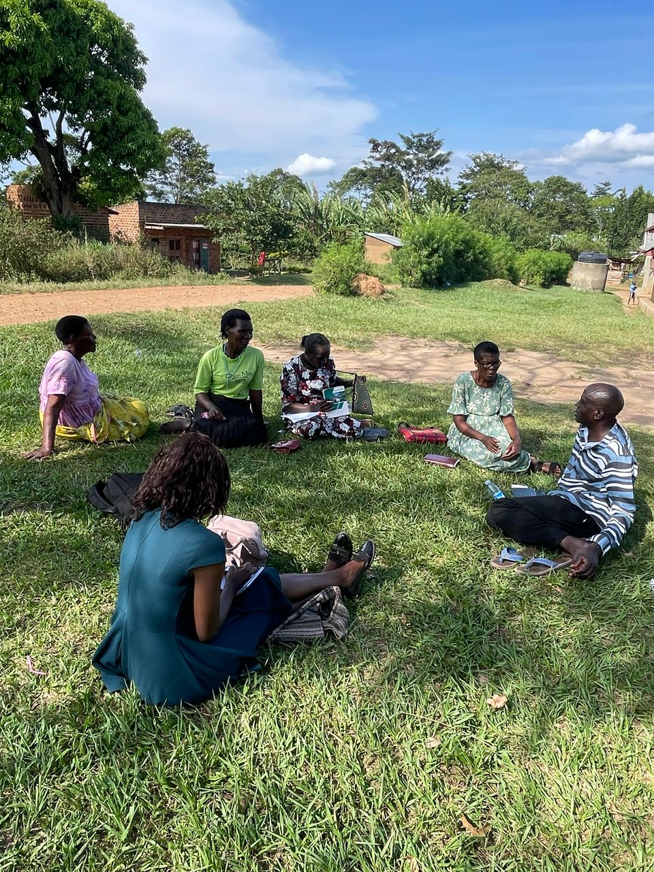

*Omni Med staff meeting with Kulubbi VHTs*

**AOB**

The government of Uganda is set to launch a nationwide malaria vaccination campaign starting April 2025. This program is part of the government’s efforts to reduce the burden of malaria, which disproportionately affects children under five and pregnant women. The government has partnered with international organizations and local health authorities to ensure the successful roll out of the program. VHTs will play a crucial role in disseminating information and administering the vaccine.

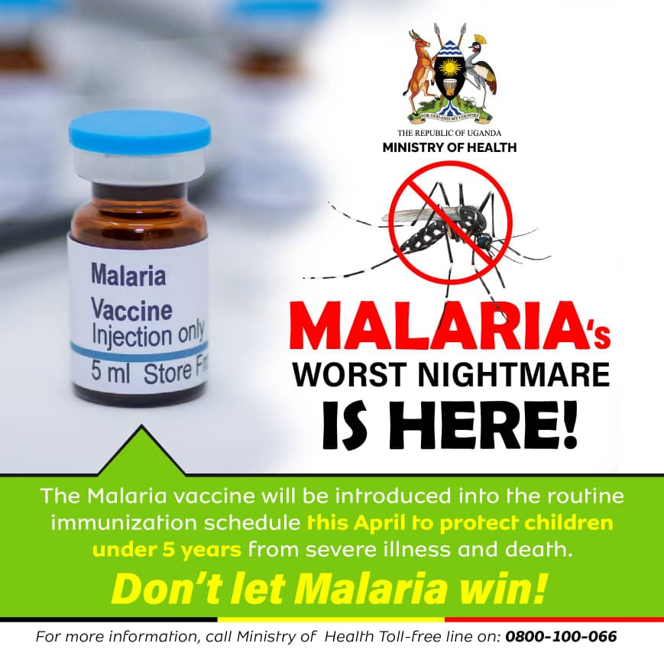

Our Peace Corp volunteer Kristin had the opportunity to work with the Nile Explorer Bus. The Nile Explorer is a project from the U.S Mission which works to enrich educational experiences of Ugandans in undeserved and under-resourced areas. The bus travels around the country to empower and equip Ugandan youth with the skills and resources critical to being an active, engaged citizen.

The Nile Explorer bus spends one week at each of the target schools teaching STEM education, computer skills, health information and civic engagement. A secondary goal of the bus is to expose the students to American culture and educational opportunities to broaden their horizons. Kristin assisted the bus staff during their stop in Lwabiyata SEED Secondary School in Nakasongola. Kristin provided these eager students with a glimpse of what life is like outside their remote village. She used this opportunity to not only highlight the differences but also the similarities between the U.S and Uganda. She also used this chance to review basic health and WASH practices, emphasizing the importance of taking control of our own health and life.